Trp-fluorescence spectrometry for the study of CDF proteins CTDs’ interaction with divalent transition metal cations (using Fluorolog®-3 by HORIBA Scientific)

- Initiate the instrument:
  - Lamp: press the lower button (fan) and then the upper button (lamp)
  - Switch on the detector (the upper button in the box above the detector)
  - Switch on the apparatus that looks like a computer box (near the computer screen). You should hear one beep and after few seconds another two beeps, this means that the instrument is ready for use
  - The measuring cell should contain a holder that fits for a quartz 1 mL cuvette
  - To use the computer, log in to your payment account (regular BGU user and password)
- Make a measurement:
  - Open the “FluoroEssence” software
  - If in the pop-up window that shows you the instrument components, other components than the “temp control” appear, it means that you did not initiate the instrument properly
  - In the cell, place the cuvette so that the exciting beam will go through the thin clear side of the cuvette (the first sample contains 1 mL protein solution, wash cuvette prior with MQ and buffer and verify it is dry before fill it with the protein solution)
  - Press the “M” button. Press next spectra emission next, when the first sample (only protein) is already in the holder in the measuring cell. Choose a measuring program or define the parameters before starting the measurement. A program for MamM CTD is found in D:/Zarivach with parameters defined:
    - Slit = 7 nm (depends on the number of Trp residues, the protein concentration and their resultant intensity; MamM CTD used concentration was 5 µM of dimer with one Trp per monomer)
    - Excitation wavelength = 297 nm (specific for Trp, you can also use 280 nm)
    - Emission spectra = 310-450 nm, recorded every 1 nm
  - Define project name. All measurements will be appeared under this name, numbered
  - Press run to make another measurement under the same conditions
- The graph of interest is that of the S1C/R1C. If the graph is bumpy, you should increase the protein concentration to increase the signal (see it in the S1 graph). A good maximum value in the S1 graph should be at around 2000 (2,000,000 in the S1C/R1C). If it’s greater, decrease the slit width. It is better when the excitation and emission slits width are the same, so change both for the same value. If needed to decrease only one of them, preferably change the emission slit width. If in the S1 graph the maximum value is less than 2000, increase the slits width. You can save the defined new program, so you can use the instrument defined parameters automatically each time you start a new measurement.
- Titration serial used for 1mL of 5 µM MamM dimer:
  - Use 2.5 mM metal solution in the same buffer
  - Add: +0, +1, +1 (total of 2), +2 (4), +4 (8), +12 (20), +30 (50), +50 (100), +100 (200) µL of the metal solution (each titration serial composed of 1 protein sample and another 8 samples of the protein with different metal concentrations). Using these protein and metal concentrations, you will get a dilution serial with protein/metal ratio of: 0, 0.5, 1, 2, 4, 10, 25, 50, 100.
  - After the addition of the metal, cover the cuvette well with parafilm paper and mix by flipping the cuvette few times gently, then put the cuvette in the measuring cell and take the measurement. In one titration serial use the same parafilm paper.
- Make each titration at least 3 times. If all titrations were measured fine, you should get files named 1-27 to each protein-metal pair. Samples 1, 10 and 19 are of protein solely, samples 2, 11 and 20 are protein + 1 µL metal solution, etc:
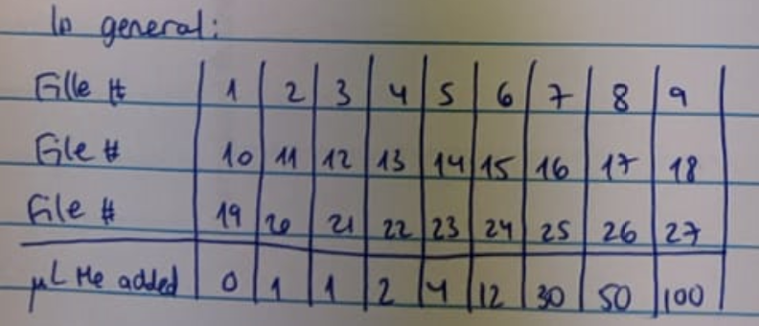
- After each titration serial, wash the cuvette with MQ and buffer. Make sure the cuvette is dry before refilling it with new protein solution.
- If binding occurs – you should detect emission spectra shift when you add Zn and Cd, and spectra quenching when you add Mn, Co, Cu, Ni and Fe. Notice that you dilute the protein during the titration so you will see signal quenching anyway – to see if it relates to the binding you should normalize the signal by the factor of dilution (for example, multiple the spectra of file 5 by 1008/1000, as you added total of 8 µL of the metal solution to the 1000 µL protein solution).
- To make sure that the quenching and spectral shift relate to the binding and not to dilution effects, make one titration serial with buffer instead of metal solution, then normalize this titration serial and make sure that all samples show that same spectra.
- Save the data under your folder with whatever name you wish.
- Shut down the system: close the FluoroEssence software, then the computer-like part, then the detector, then the lamp and after 10 minutes the fan. Don’t forget to register off your payment account.
- Analysis:
You can open the data file using Origin, then in Origin you can access to each file (1-27), copy all the S1C/R1C graphs data to a spreadsheet and then manipulate it as you want. You can also export the data as ascii file. You can normalize each file according to the dilution, and to fit each of the normalized spectrum to the Extreme function in Origin (for MamM CTD, R>0.98 for all fits). This fit will give you the maximum wavelength and the intensity at the maximum wavelength (with their errors) to each measurement, you then can calculate the average values for each dilution (from the three repeats, average of files 0+10+19, average of files 1+11+20 etc.) and make a graph of maximum wavelength and the intensity at the maximum wavelength vs. protein/metal ratio (you can further normalize the maximum intensity so that the protein solely will be 100% and the rest will be normalized to its value).

