PROTEIN LABELING WITH FLUORESCEIN ISOTHIOCYANATE (FITC)
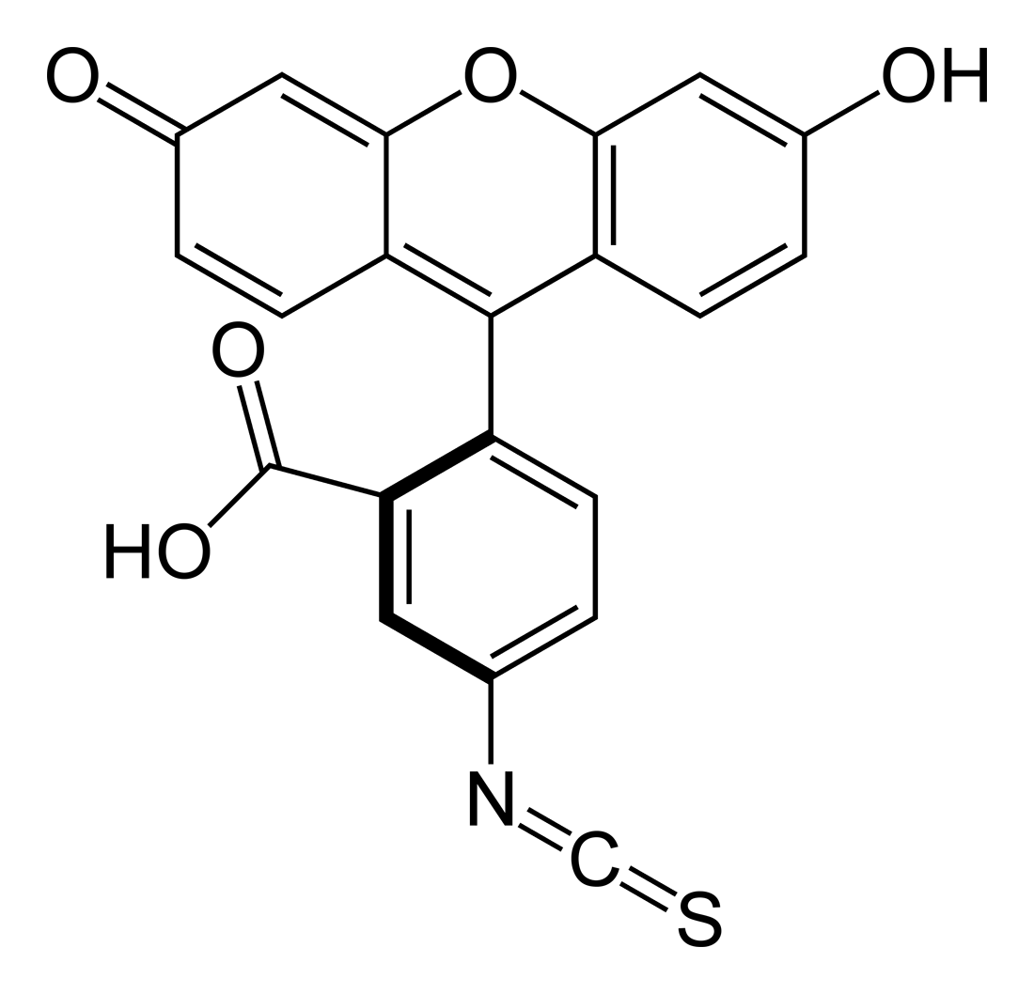

Fig: Chemical structure of FITC

Fluorescein isothiocyanate (FITC) is widely used to attach a fluorescent label to proteins via the amine group. The isothiocyanate group reacts with amino terminal and primary amines in proteins. (Molecular Weight: 389.4, Excitation: λ_{max} = 495 nm, Emission: λ_{max} = 525 nm)

Procedure:
- Dissolve your protein to concentration of 2 mg/ml in your desired buffer, pH-7.5- 8.
(Note: The protein to be conjugated should be free of contaminating proteins, and protein solutions should not be prepared in buffers containing sodium azide or amines such as Tris or glycine since they inhibit the labelling reaction. If the buffer contains amines or sodium azide, dialyze protein solution against PBS, pH 7.4, overnight at 0- 5 °C. Avoid dialysis at high pH values (> 8.0-8.5) as this may be harmful to some proteins.)
- Dissolve FITC in DMSO to a concentration of 1 μg/μl.
- Add the FITC solution to the protein solution to get a final concentration of 100 ng FITC per 1μg protein. Mix immediately with continuous stirring condition. Try to conduct this experiment in dark because FITC is light sensitive.
(Note: FITC becomes activated when it will be dissolved in DMSO. It is good to use freshly prepared FITC solution)
- Wrap the tube in aluminium foil and incubate at room temperature for 90 min.
- Remove excess FITC and exchange the protein into storage buffer by gel filtration. First stop the column flow, then carefully layer the reaction mixture onto the top of the column. Then open the column, allowing the reaction mixture to flow through the column. Just as it all enters the column bed, carefully add PBS or your desired buffer to the top of the column. Two bands will form on the column. The faster moving band, which is the conjugated protein, elutes first and can usually be seen under room light. The slower moving band is the unreacted (free) FITC.
- Collect the conjugated protein fractions and store it at 4˚C.
- You can run your conjugated protein on a SDS-PAGE. If your protein is tagged you will see a yellow smear and under UV light it will show fluorescence.

Written by
Baisali Bhattacharya
Prof. Raz Zarivach Laboratory
23.10.2018

